Using AI for personalized language learning: A practical exploration of Duolingo

Author: Tazreen Jahan (NSU ID: 2221670630)

Introduction

Duolingo is an AI-powered language learning platform designed to help users learn new languages through interactive and adaptive lessons. It is widely used for improving vocabulary, grammar, pronunciation, and conversational skills. The app uses AI to personalize lessons based on user performance and learning speed. This makes it especially useful for beginners who need structured guidance as well as for intermediate learners who want consistent practice. Duolingo is valuable because it provides an accessible and engaging way to learn languages anytime and anywhere.

Prompt

Unlike traditional AI tools like ChatGPT, Duolingo does not rely on typed prompts. Instead, user interaction acts as input.

Input prompts:
- Selecting a language, like English to Chinese.
- Answering translation questions
- Speaking into the microphone for pronunciation
- Choosing correct words or phrases
- Making mistakes during lessons
- Choosing correct words or phrases
- Making mistakes during lessons

Optional Inputs:
- Speaking exercises
- Listening exercises
- Practice mode for weak areas

Output

Text Output:
- Correct/incorrect answers
- Suggested corrections
- Sentence translations

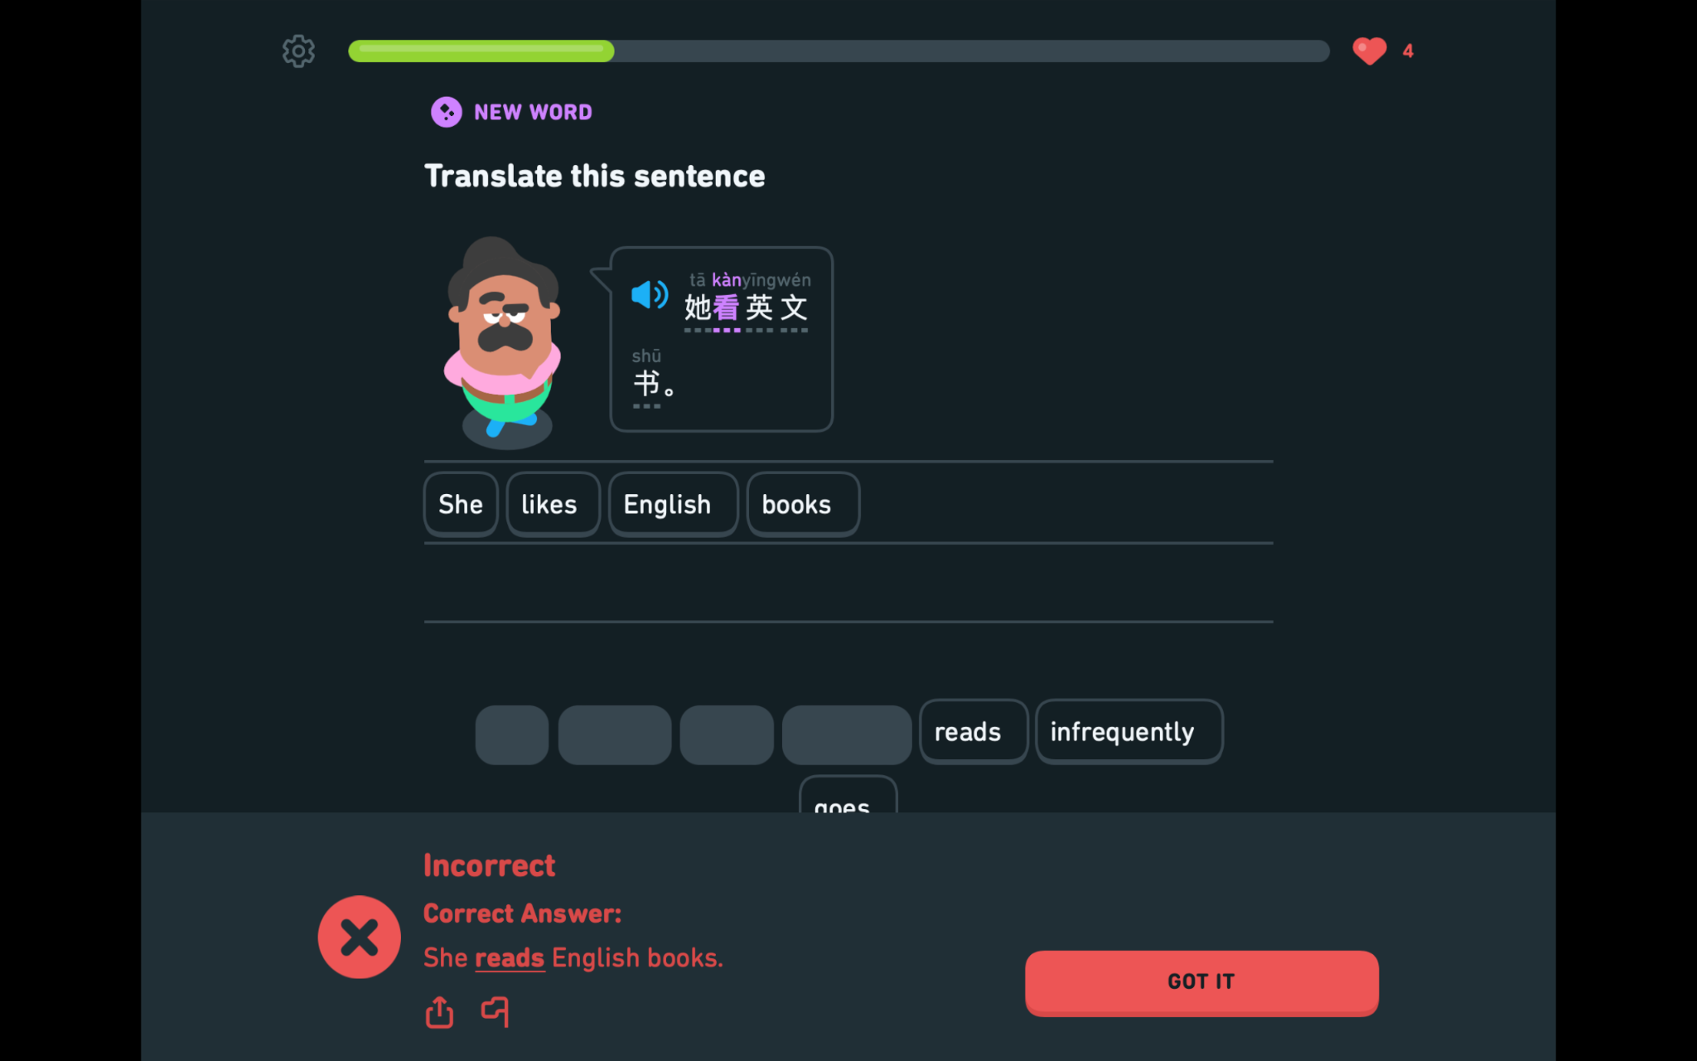

Audio Output:
- Pronunciation feedback
- Native speaker voice examples

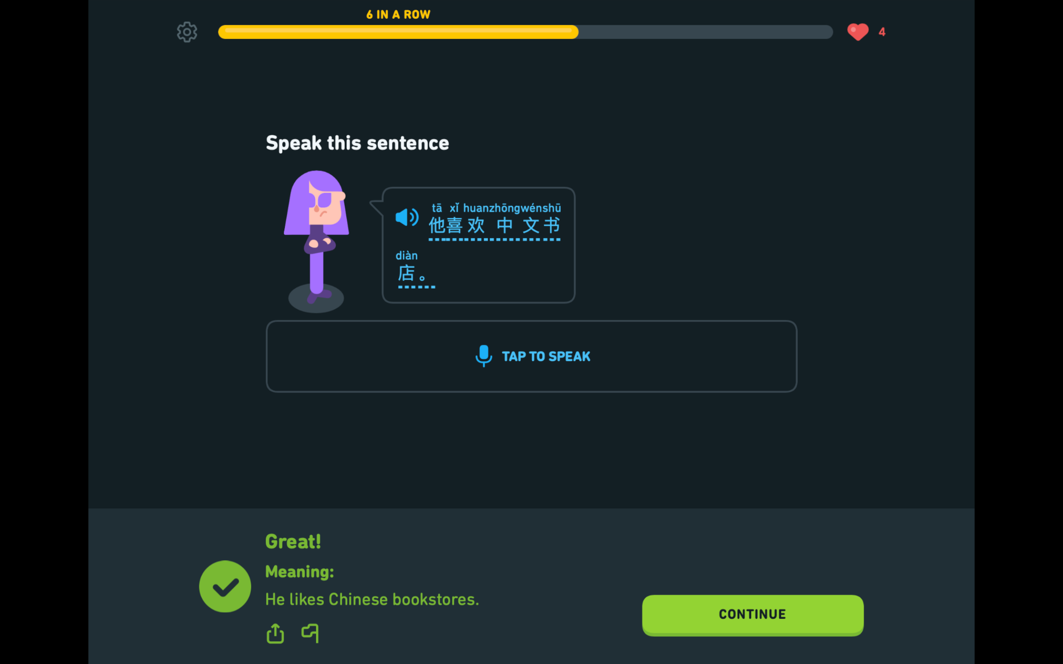

Visual Output:
- Progress tracking
- XP points and level updates
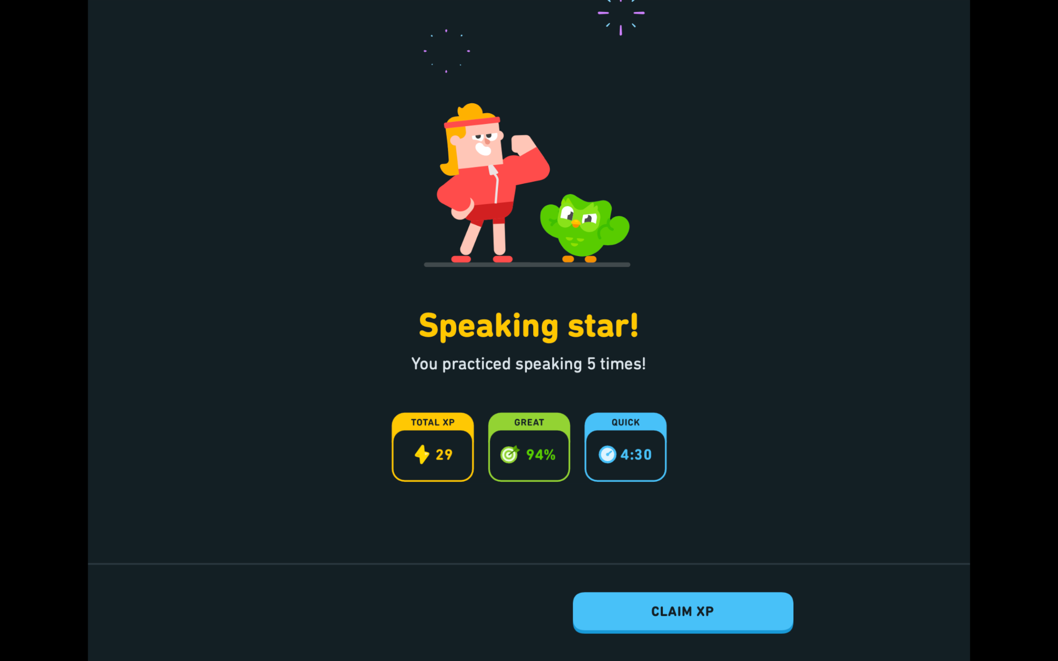

Description of Output
The output generated by Duolingo is immediate and interactive, providing real-time feedback on user performance. When a mistake is made, the system corrects it and often explains the correct answers. The AI also adjusts the difficulty level depending on how well the user performs. Additionally, the app’s AI tracks progress visually, motivating users to continue learning. Overall, the output is dynamic and personalized rather than static.

Prompt Engineering
- Consistent daily practice:
Regular interaction helps the AI better understand the user's learning pattern and adjust difficulty accurately.

- Enable speaking exercises:
Using voice input improves pronunciation feedback and activates speech recognition AI.

- Practice Mistakes:
Focusing on mistakes allows the AI to reinforce weak areas using adaptive learning.

- Avoid guessing answers randomly:
Honest attempts help the AI model to accurately track your knowledge level.

- Use listening exercises actively:
Engaging with audio improves comprehension and allows AI to evaluate listening ability.

- Repeat lessons instead of skipping:
Reinforces memory through spaced repetition, a key AI-driven feature.

- Turn on notifications and reminders:
Helps maintain consistency, which improves AI personalization.

Conclusion
Duolingo is an effective AI-powered tool for language learning, particularly for beginners and casual learners who benefit from short, engaging lessons. Compared to other language learning platforms like Rosetta Stone and Babbel, Duolingo stands out for it gamified approach and free accessibility. While Rosetta Stone focuses more on immersive learning without translation and Babbel offers more structured grammar explanations, Duolingo excels in personalization through adaptive AI and user engagement. However, Duolingo may lack the depth and real-life conversational training provided by some of these alternatives. Therefore, it is best suited as a foundational or supplementary tool rather than a complete solution for advanced language mastery.

